**LAB 2: CREATING ID CARD USING PHOTOPEA**

In this lab, we used photopea for creating a model of ID card.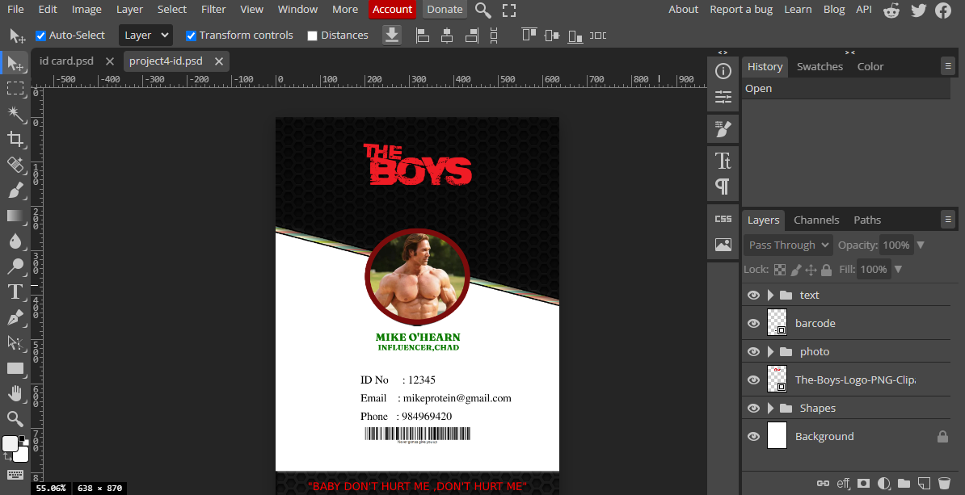

ID CARD

ID CARD EDITING

We used the following tools for creating the ID card:

1. Shape tool: First I selected a Shape(rectangle)to create overlay design for the card
2. Guide: I used guides to help me with editing to be clearer.
3. Text tool: I used text tool keep all the necessary information for the text area
4. Clipping mask: I used a clipping mask to clip my photo inside the eclipse I created.

I first took the guides for my easiness and then I created the required shape and for the logo I selected it in png format with no background. Then After I created a clipping mask around the circle so I could easily put my image and at last I kept text required as necessary to my liking.

By using all the following tools and editing the colors to our liking we created the ID card and grouped together the related elements for our understanding.